AWS ASSIGMENT

Q1. Launch t2.micro instance and install httpd server on it with custom html page saying “Welcome to my page” using user data script. Access the same on your browser.

1. Below screenshot shows User data script which has to be taken before launching instance

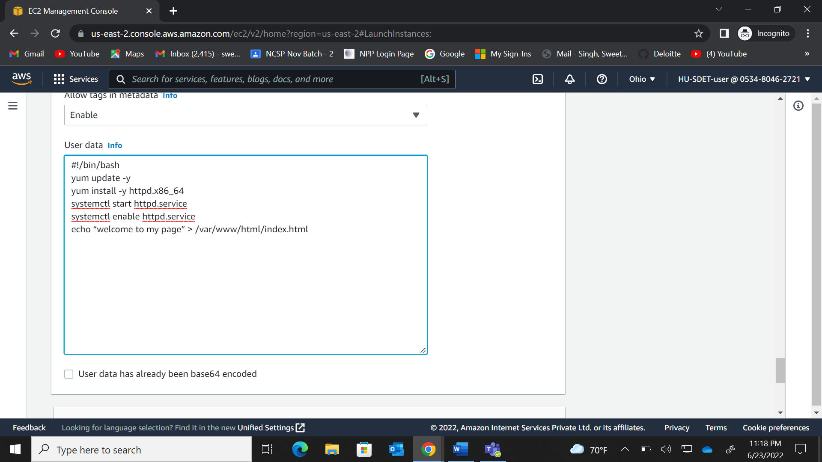

1. The instance running on the console.

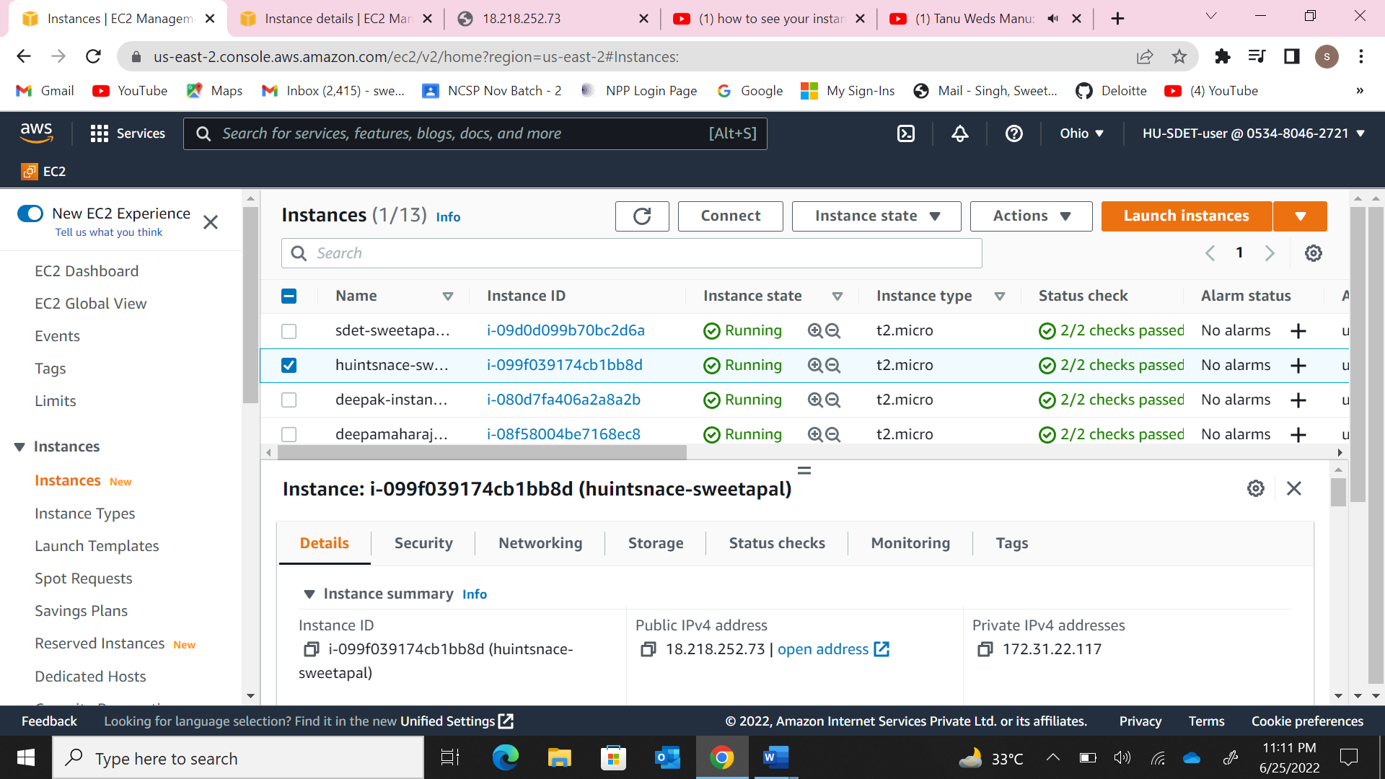

1. Security group rules.

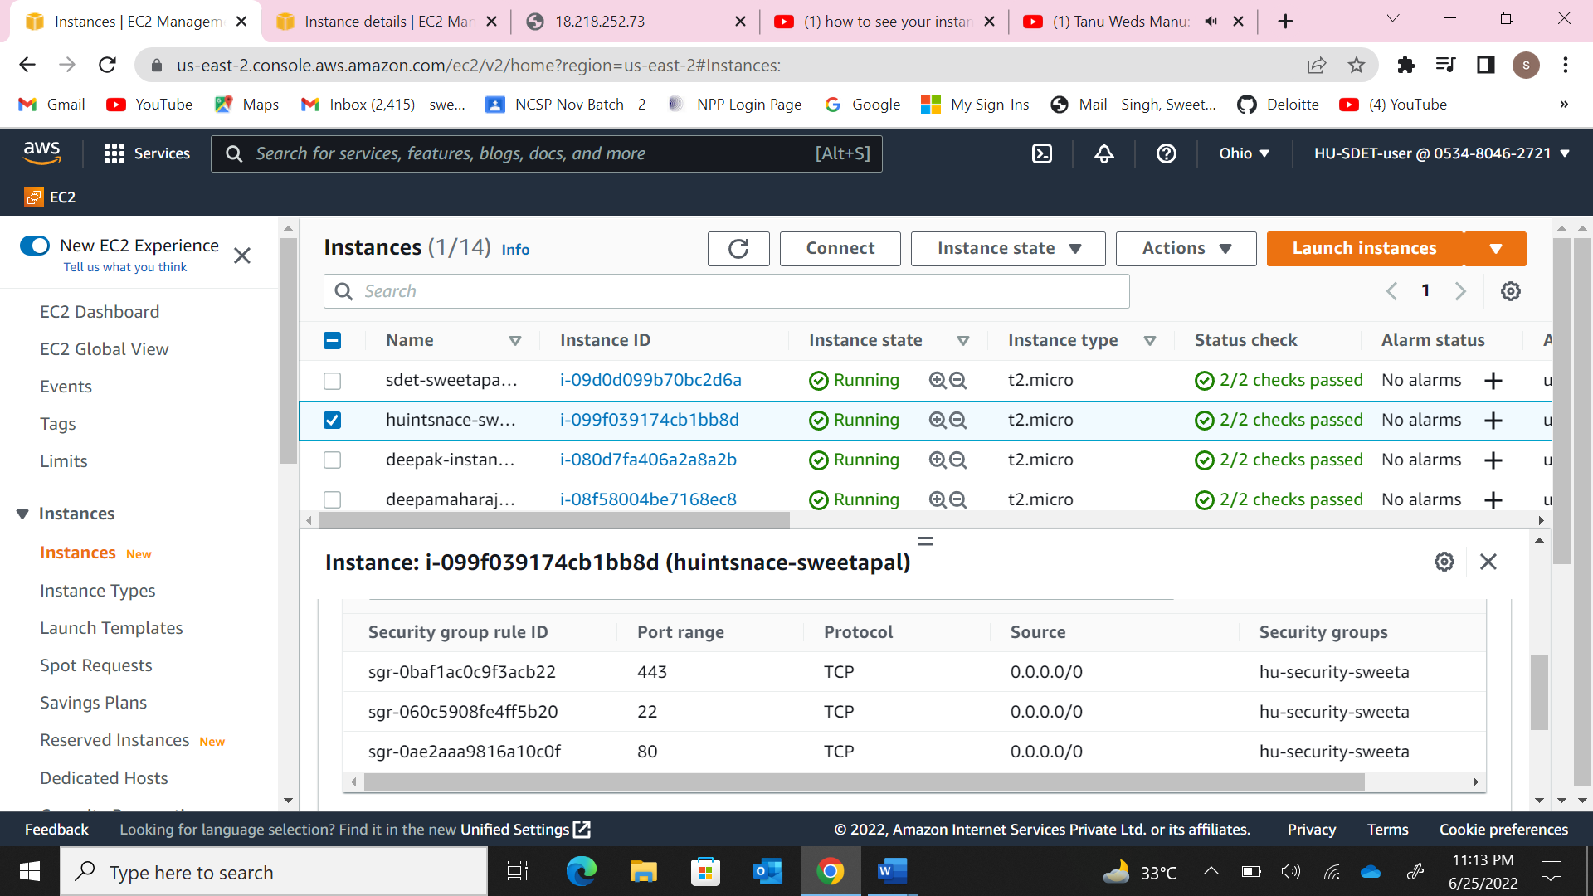

1. The webpage accessed on the browser.

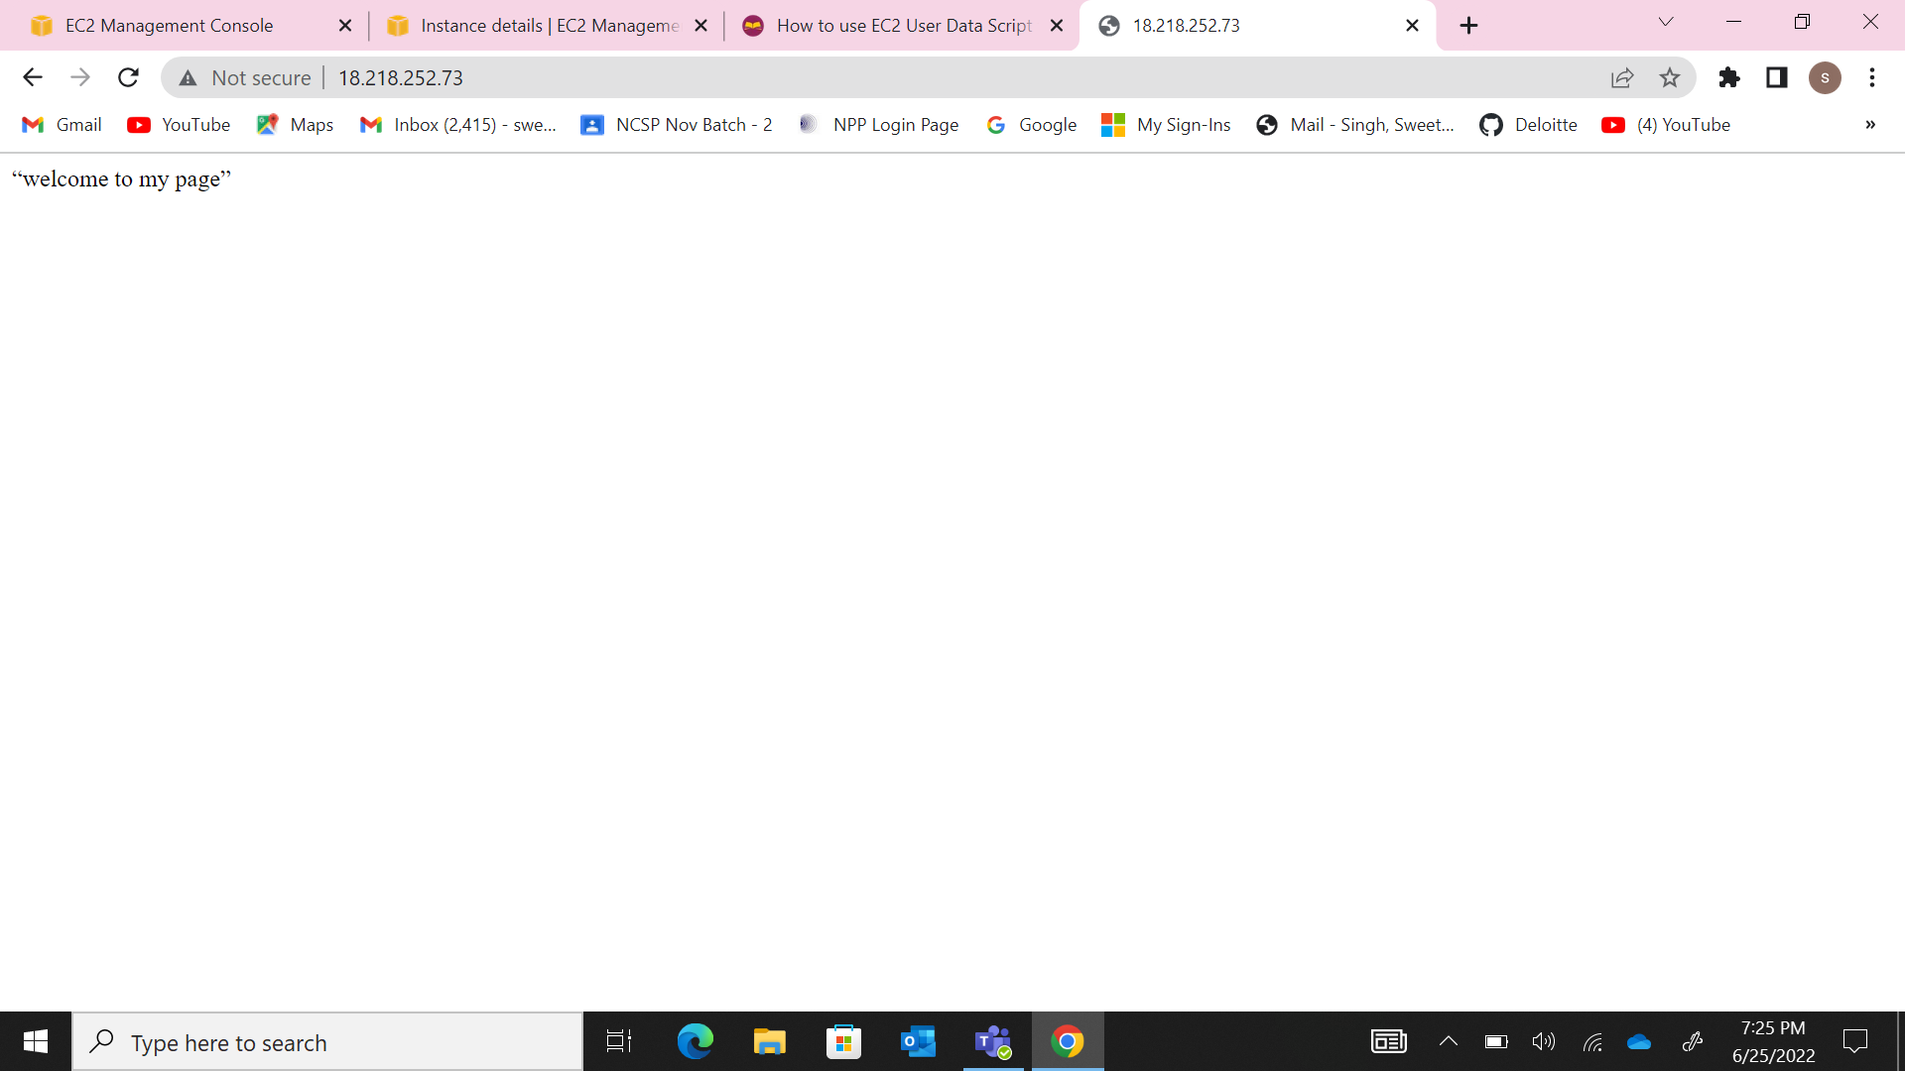

Q2. a) Launch another t2.micro instance and host the following website on it

<https://github.com/arvind37/Basic-Website-using-HTML-CSS> .

1. The instance running on the console.

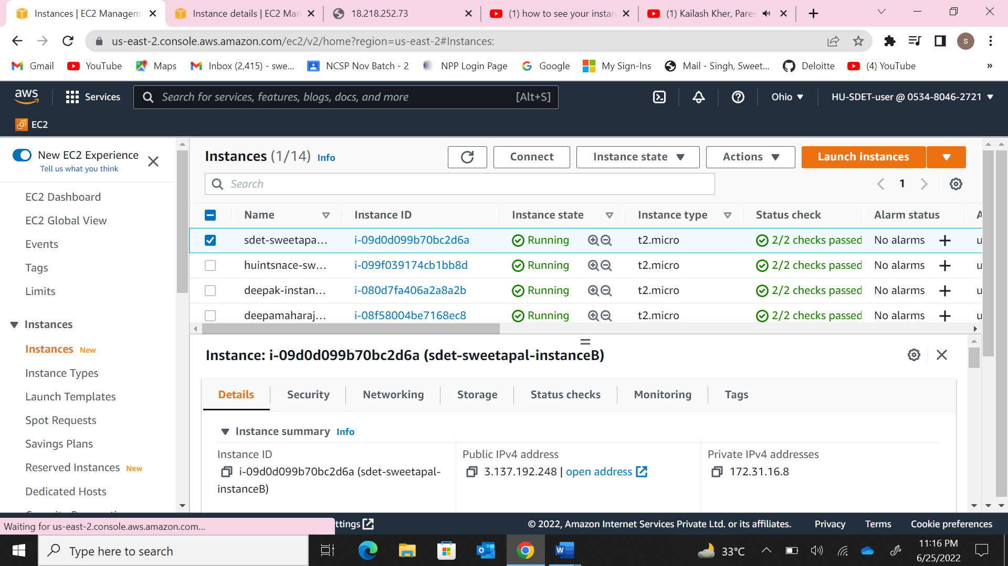

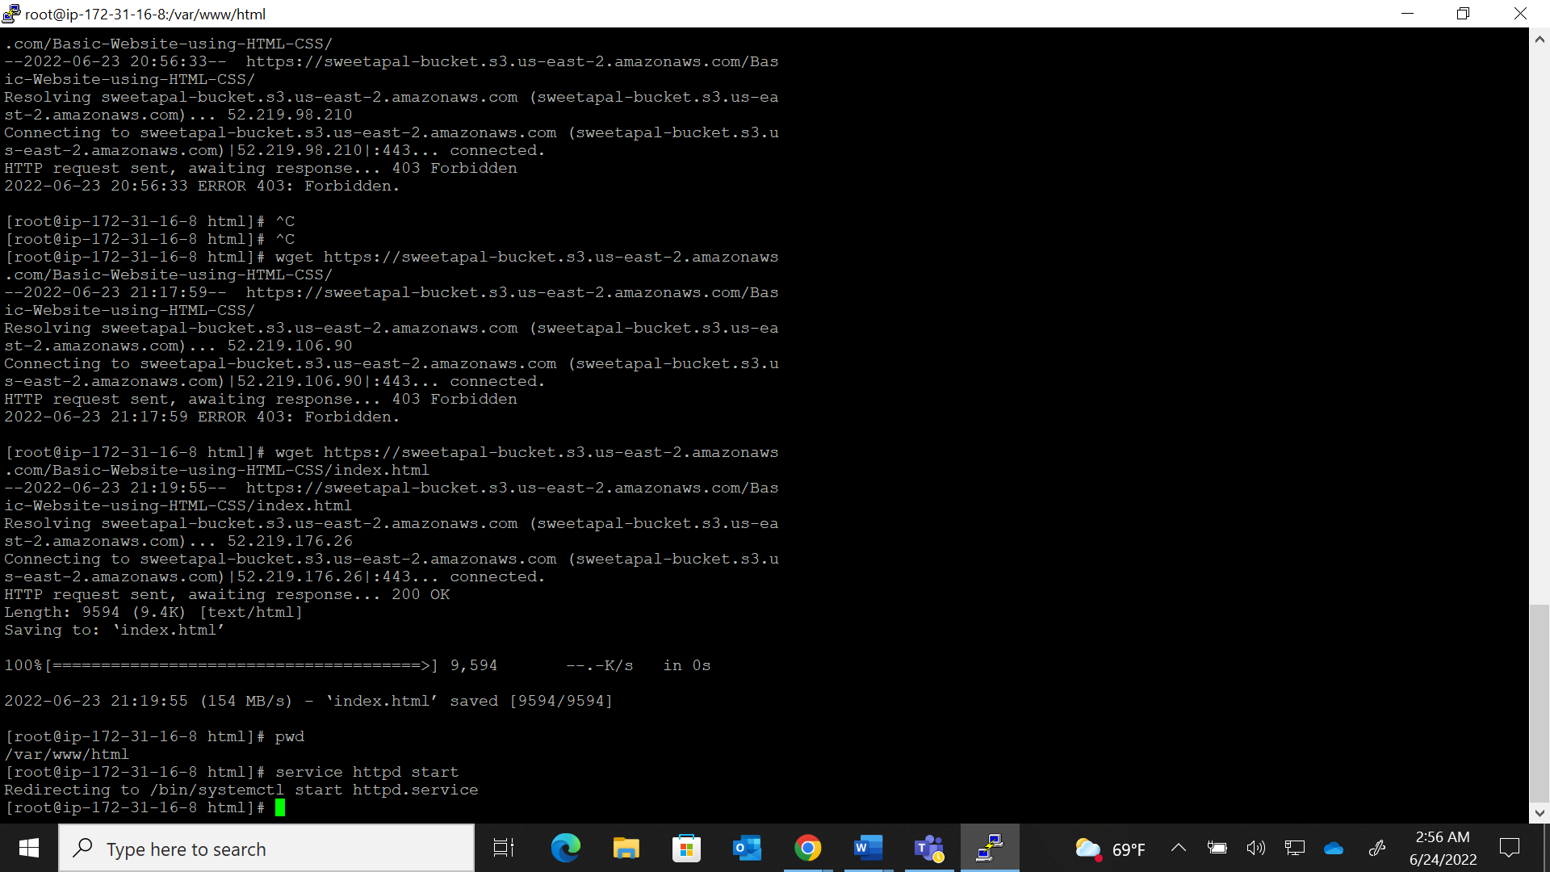

1. The webpage accessed on the browser.

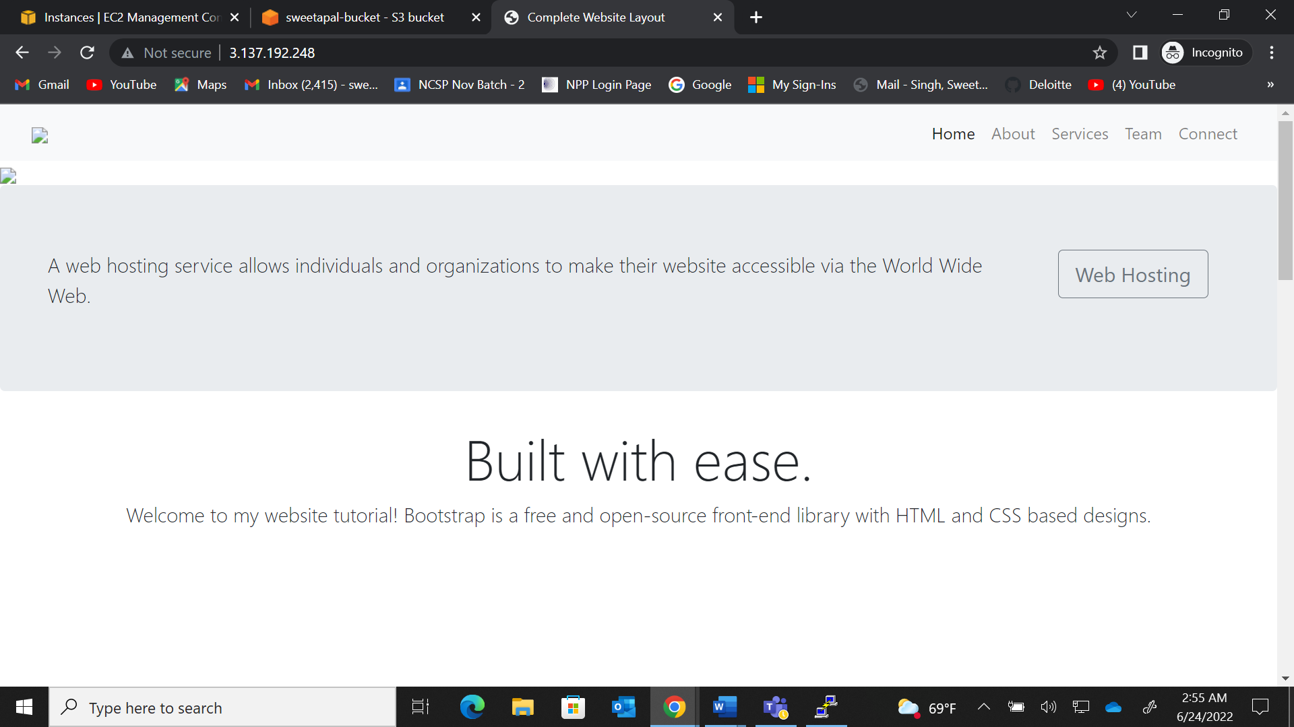

b) Create a network load balancer to distribute traffic between the instance created

in Q1) and Q2).

1. The screenshot of the NLB & Target Group.

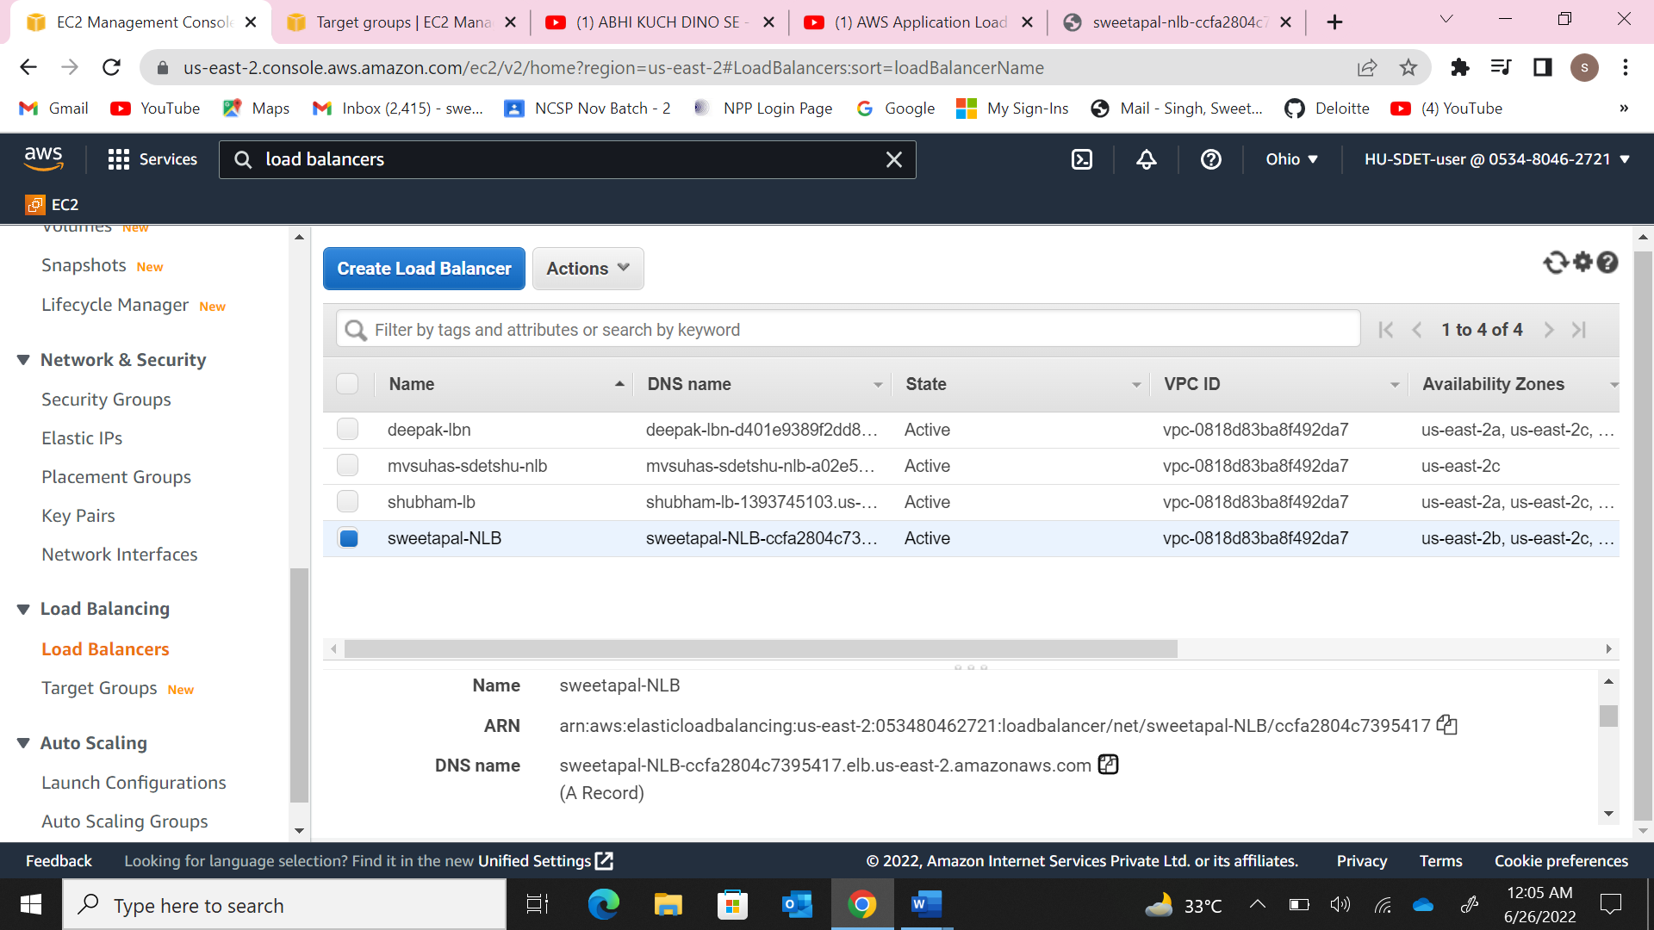

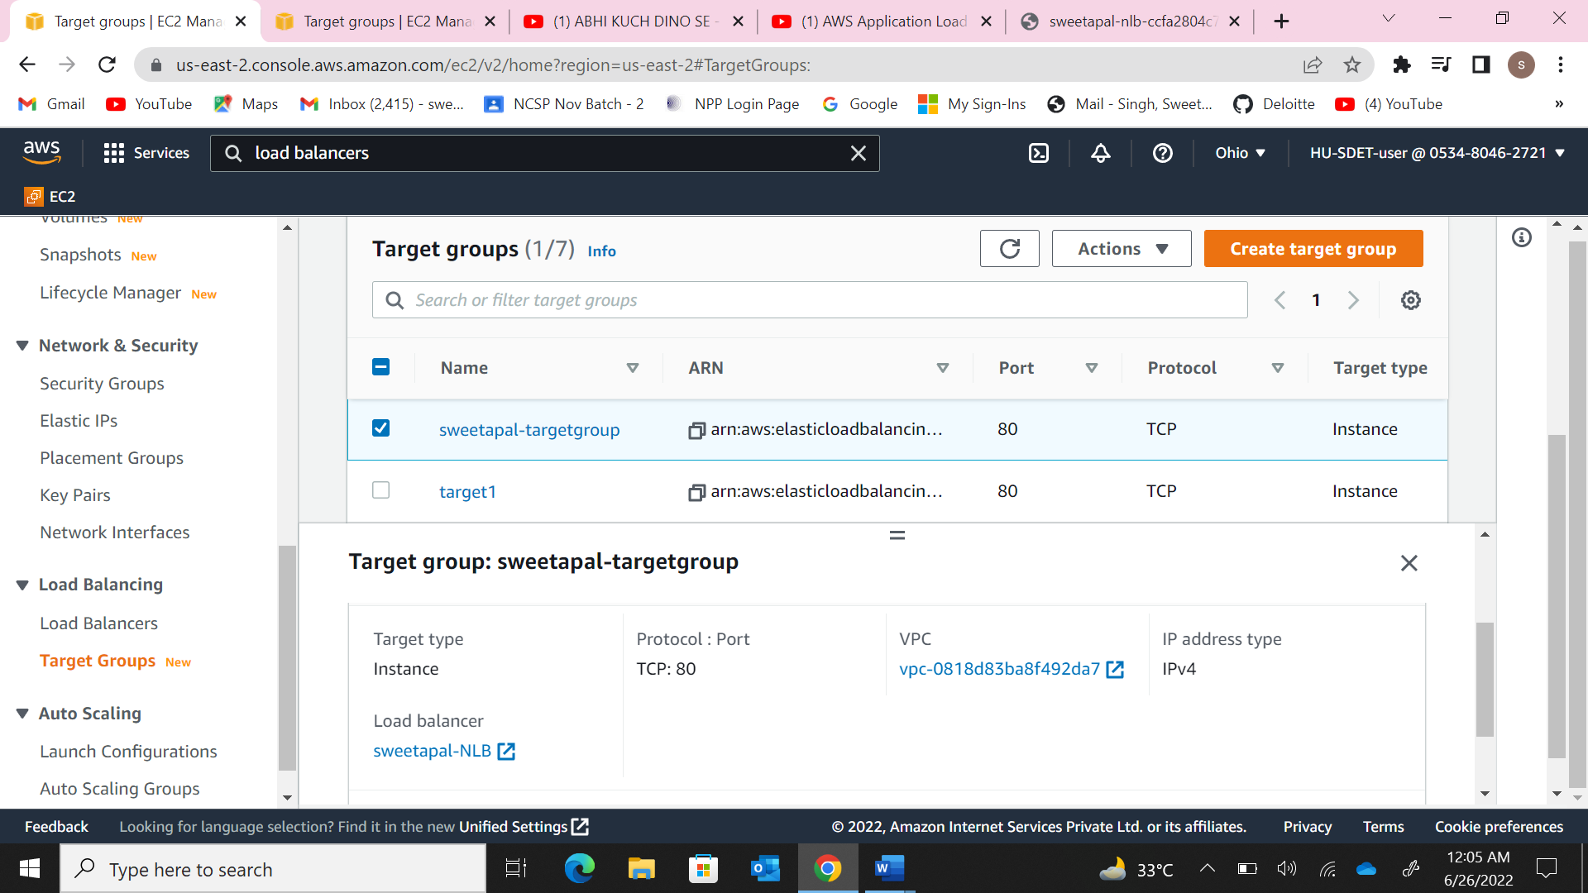

1. The screenshots of both webpages accessed on the NLB DNS.

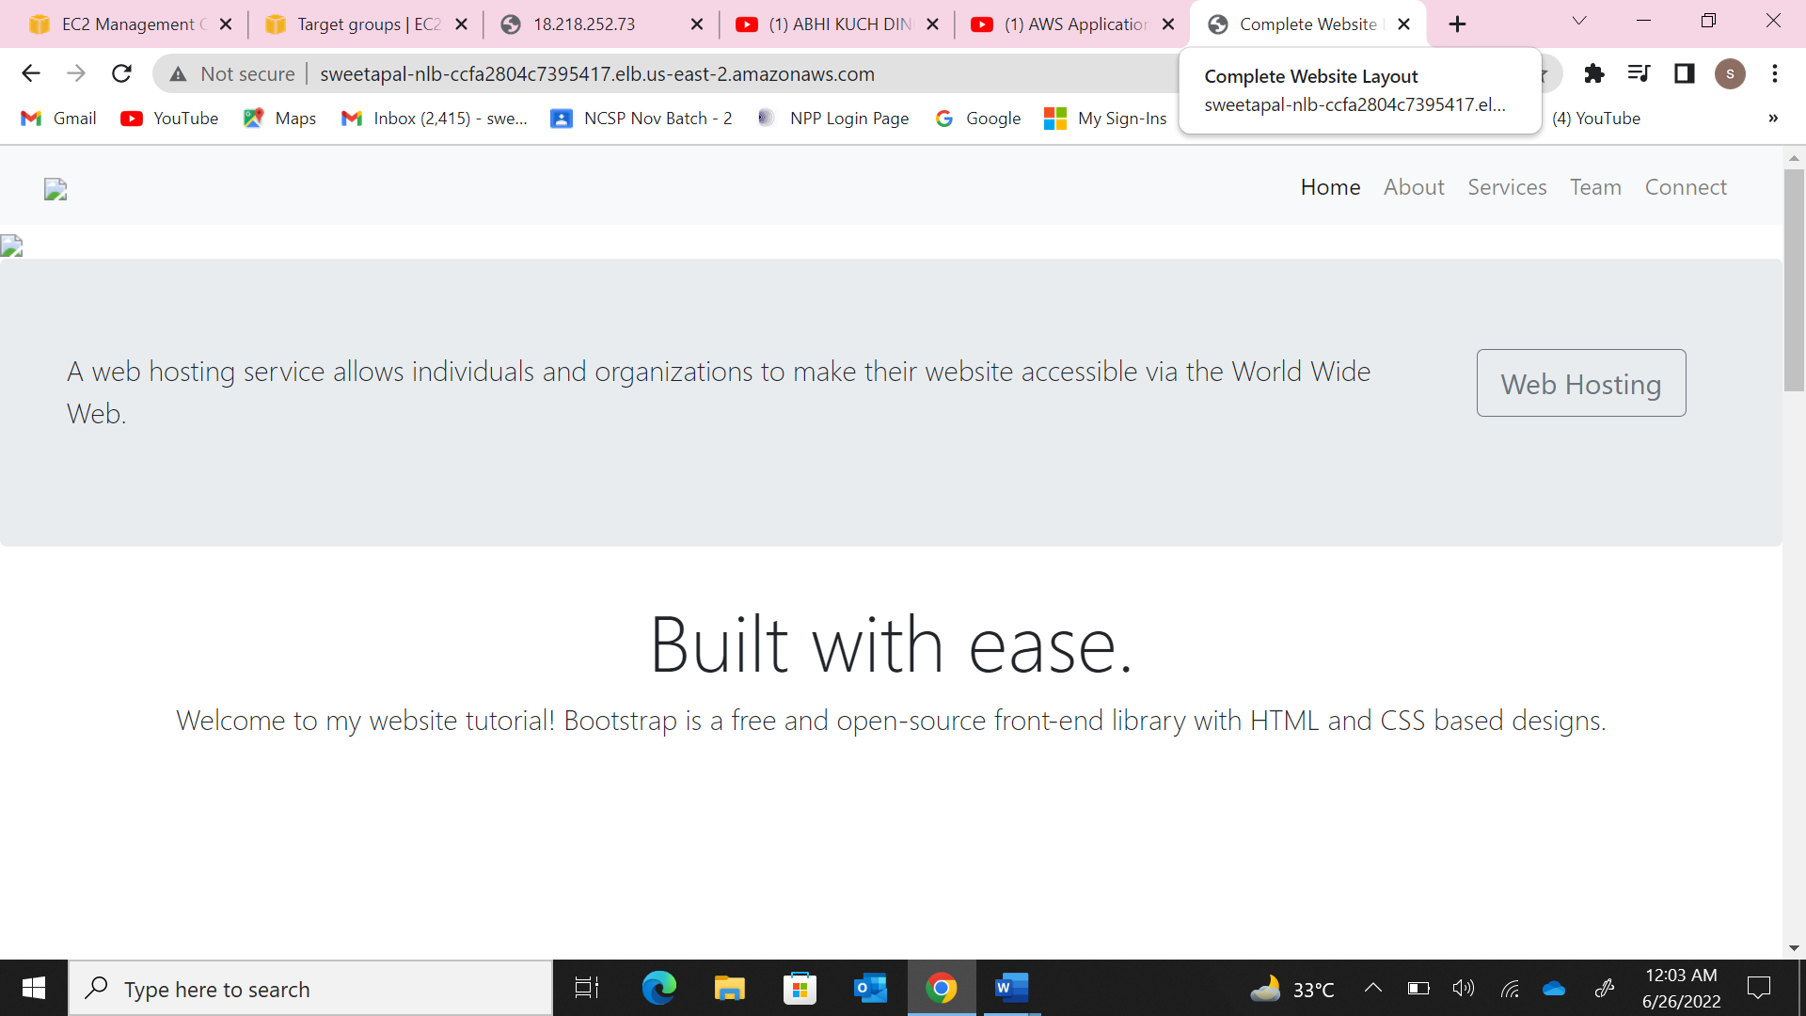

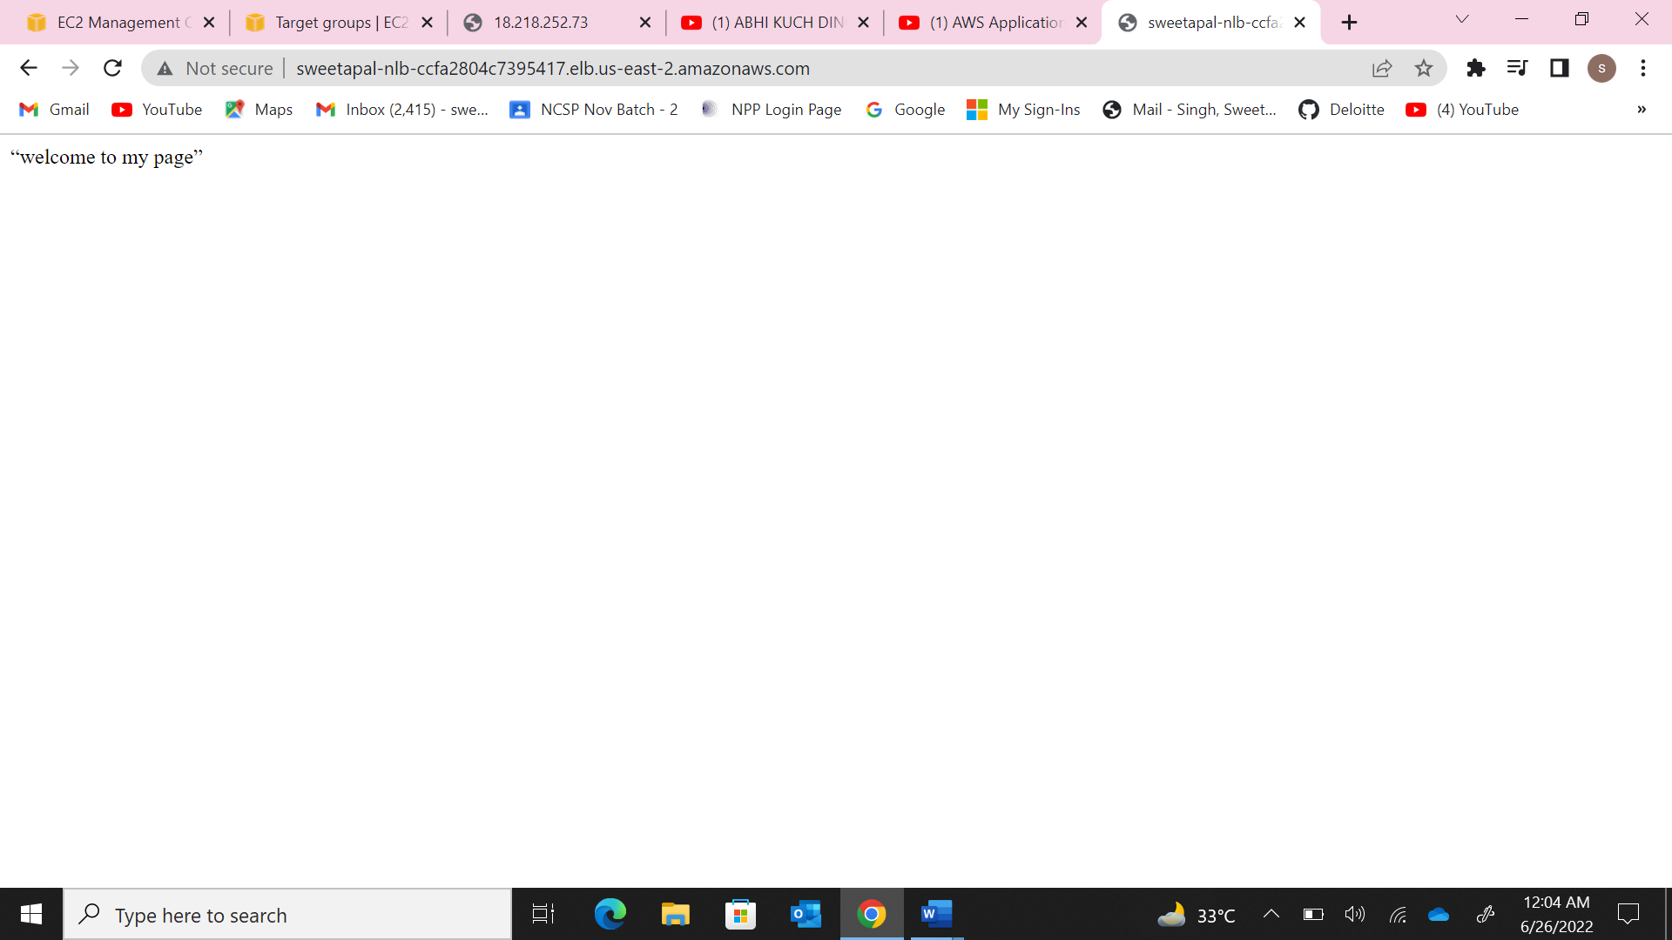

3. Create an EFS and mount on it to both the above created instances, create a file in one instance with some data which would be viewable on the other instance.

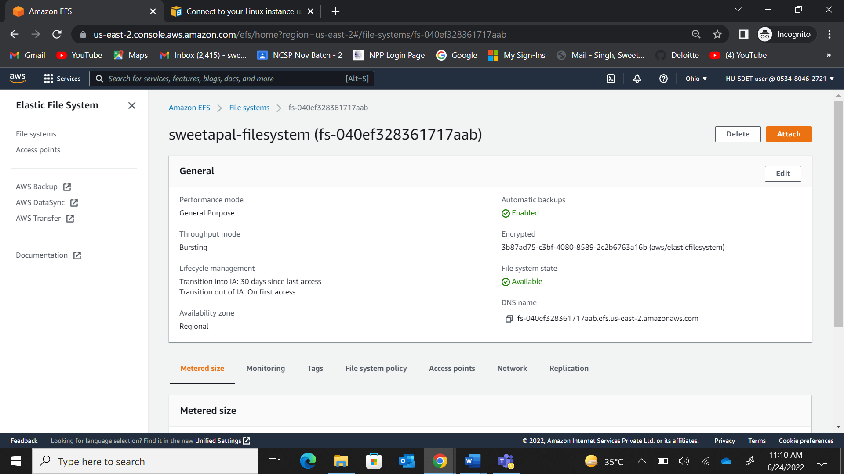

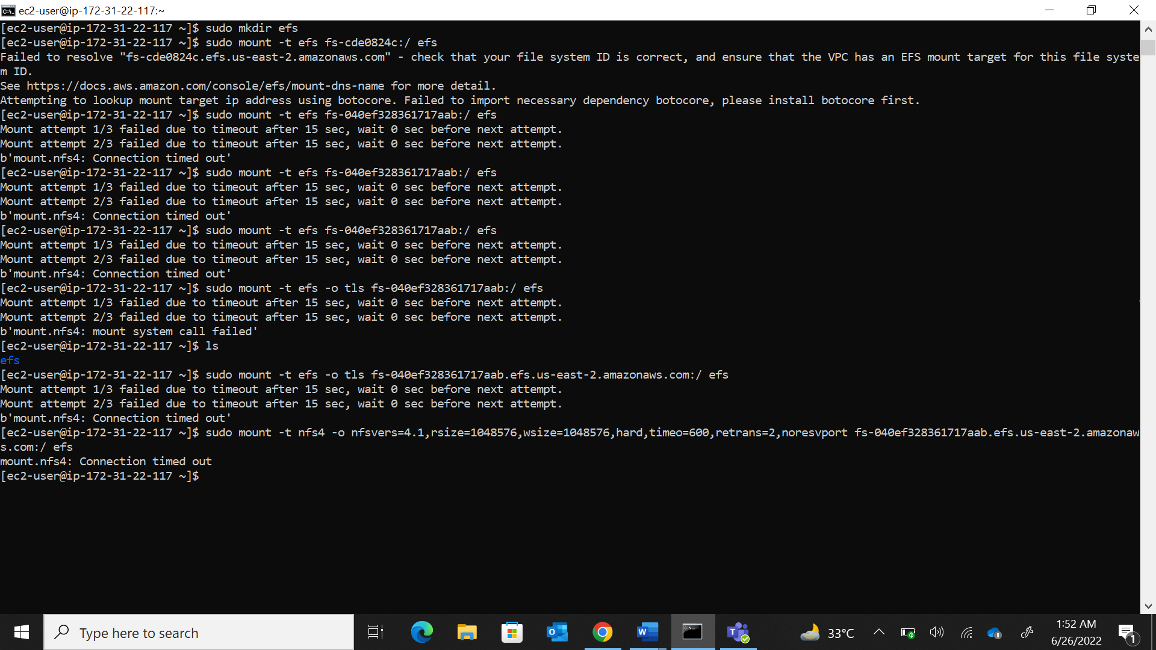

1. a). Create an s3 bucket with naming convention <your_name>_hu_devops_bucket, upload some files into. Now from your ec2 machine(Created in Q1 or Q2) list the contents of the bucket.
2. The s3 bucket with the uploaded files.

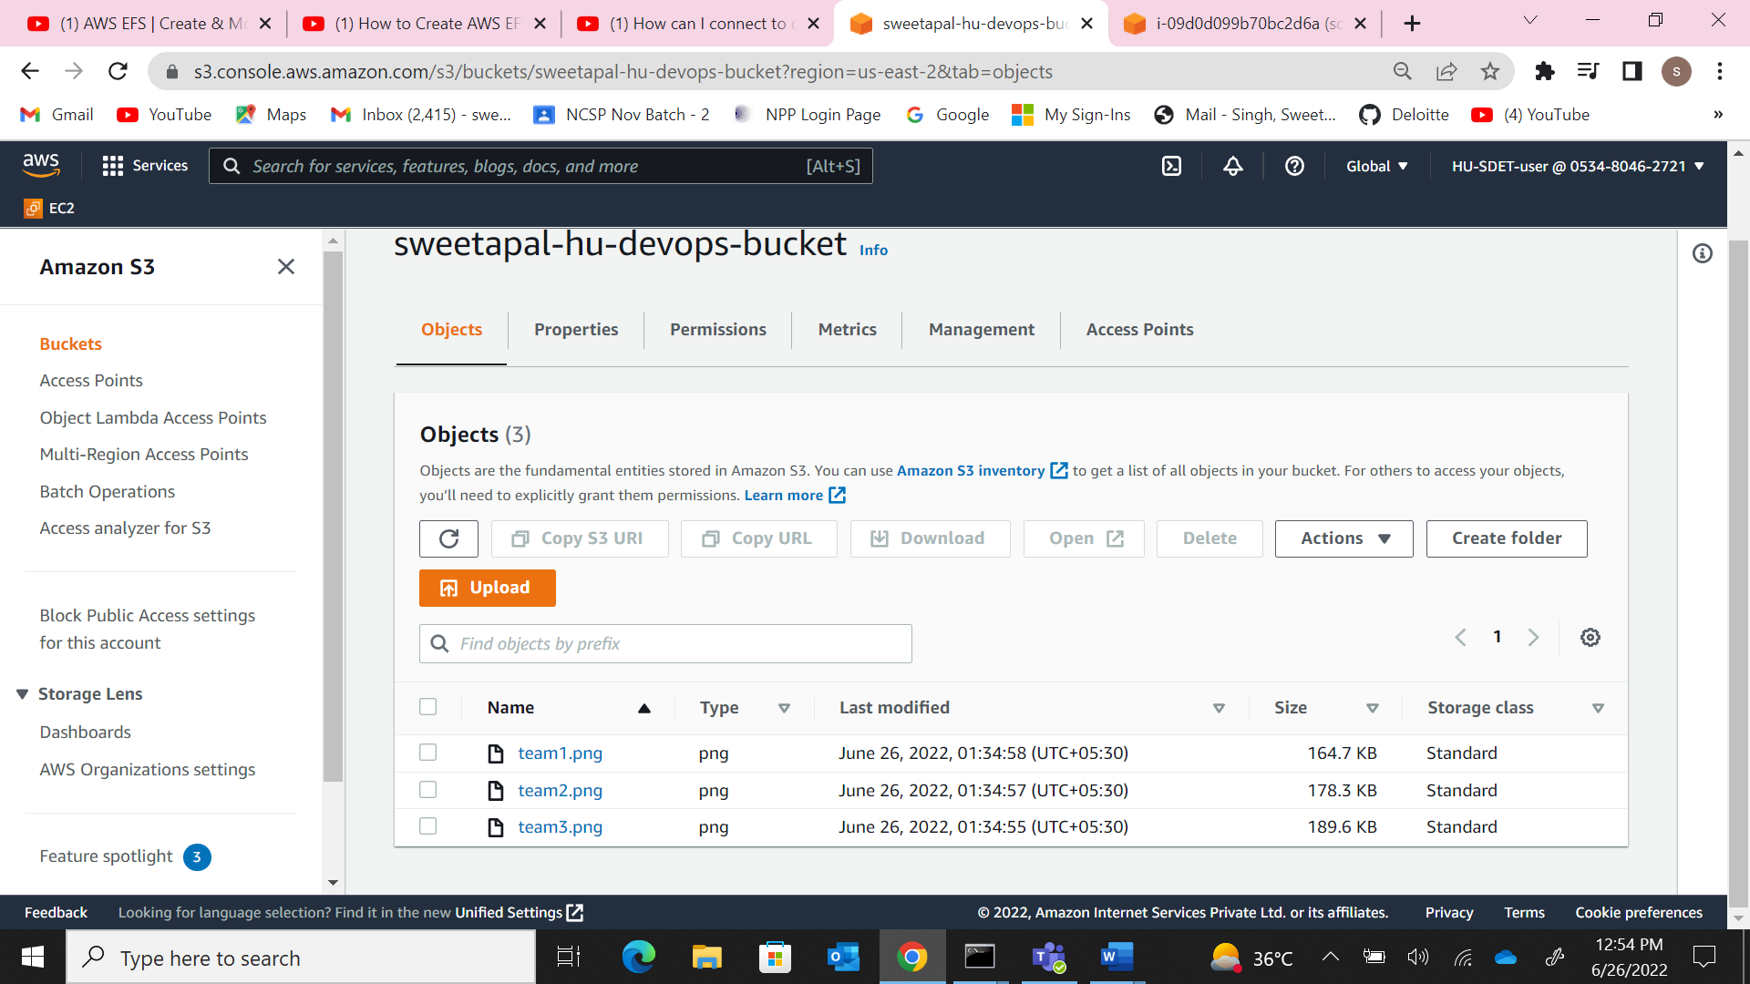

1. The role and the policies attached.

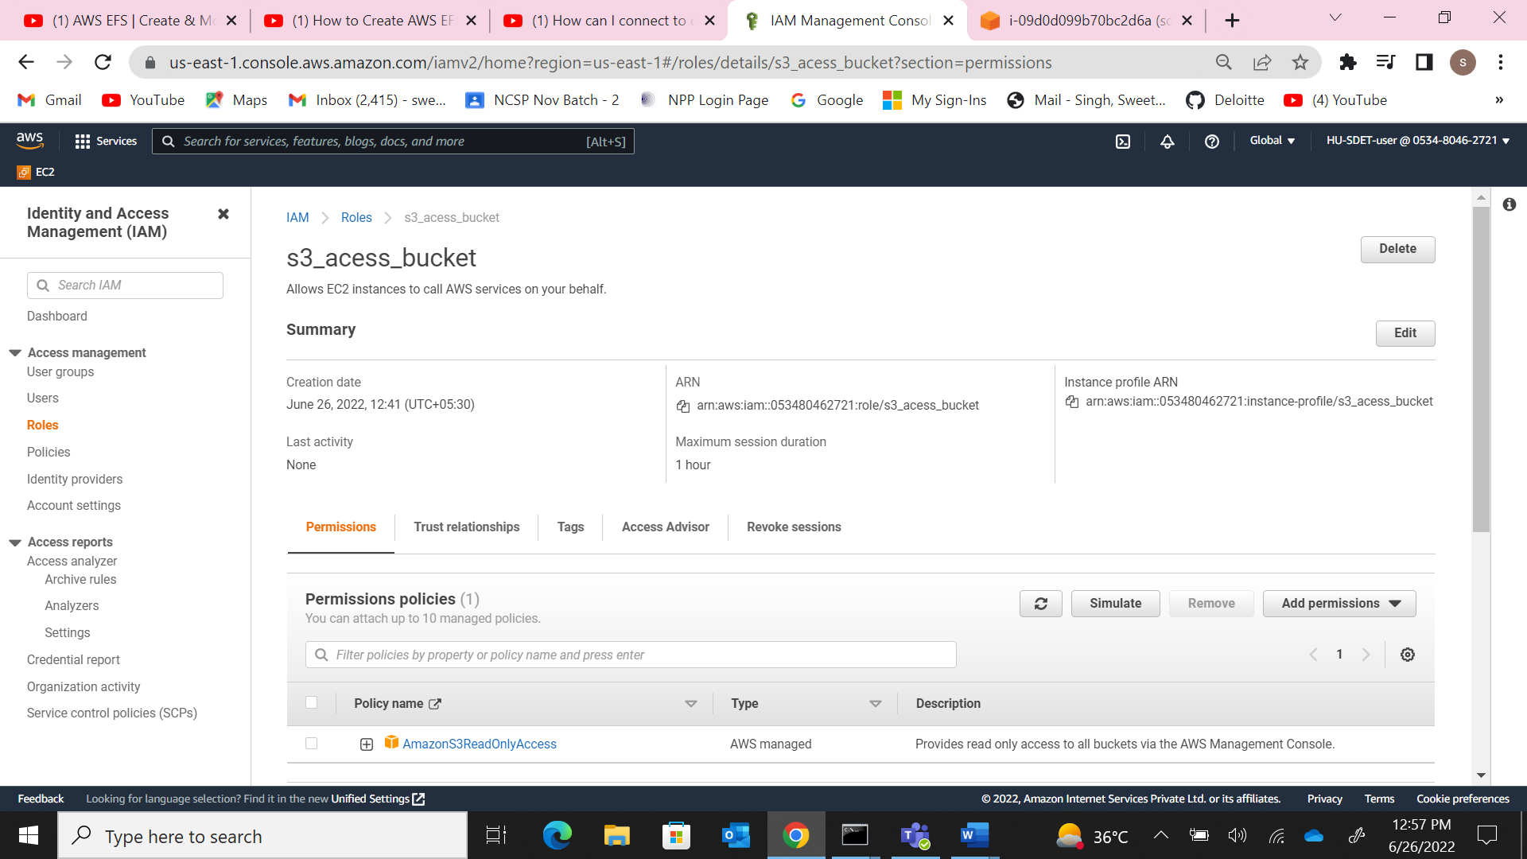

3. The contents listed on the ec2 terminal.

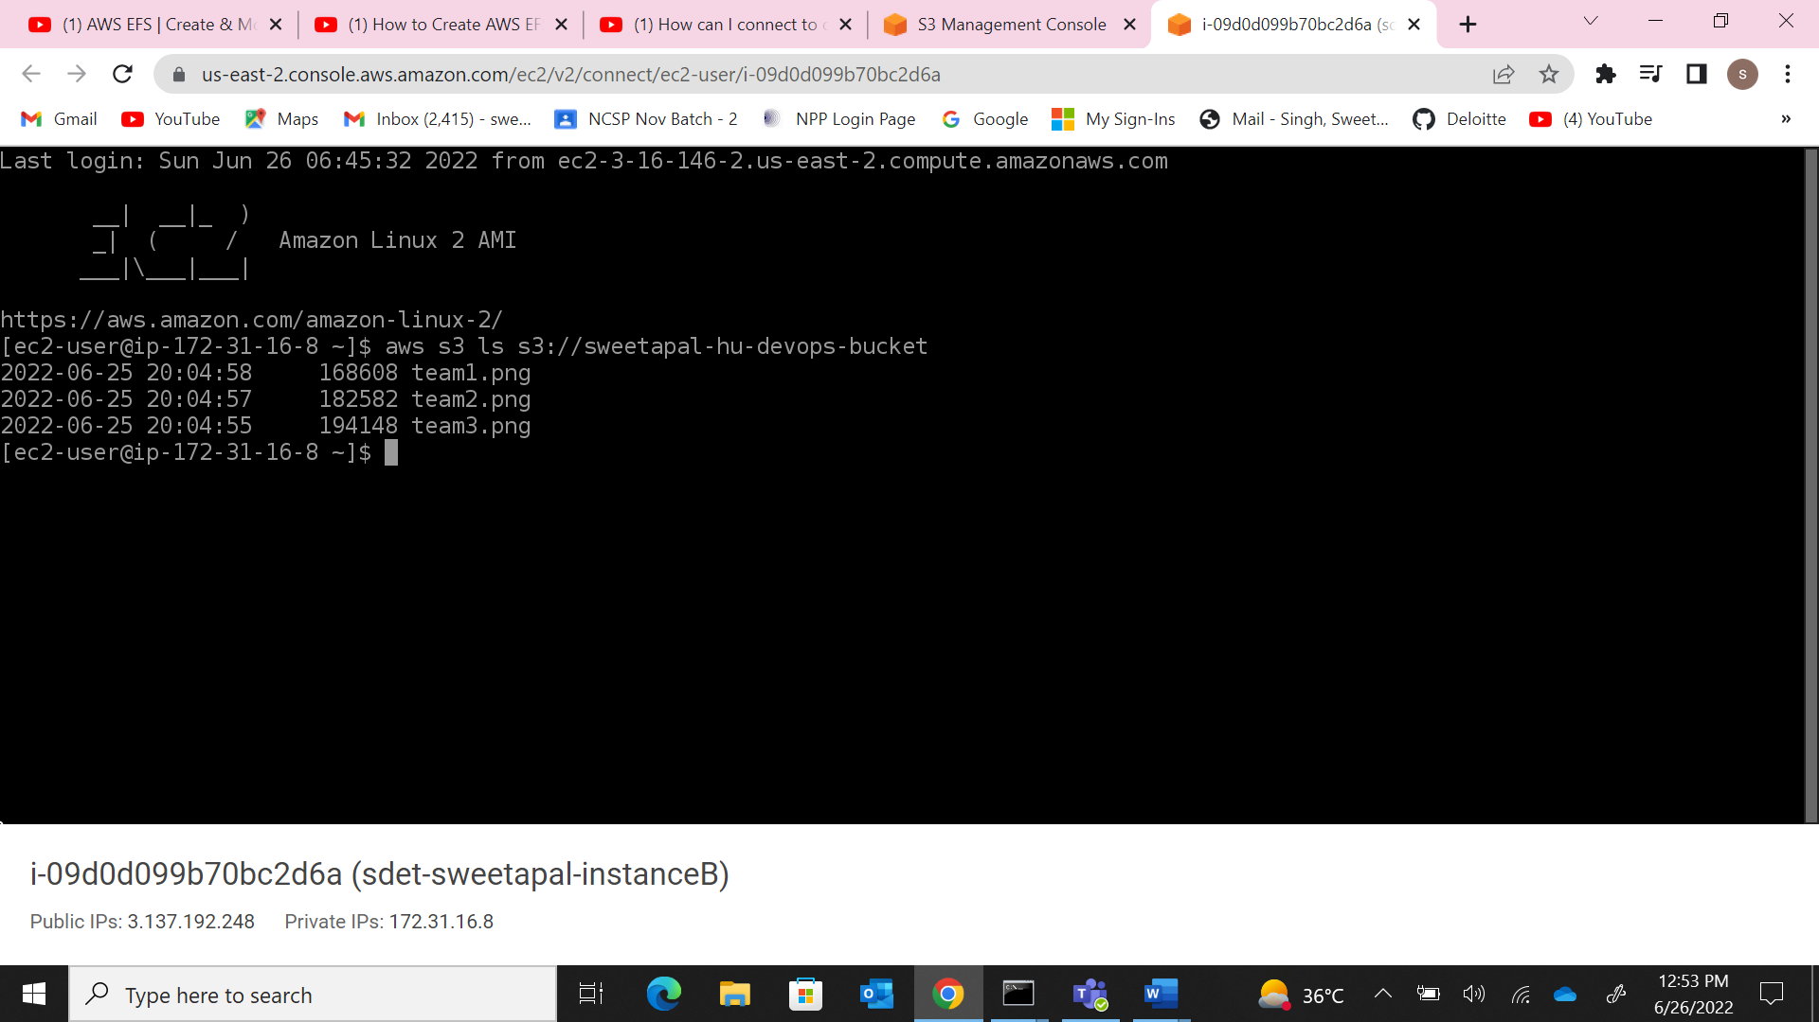

4.The lambda function with the trigger set.

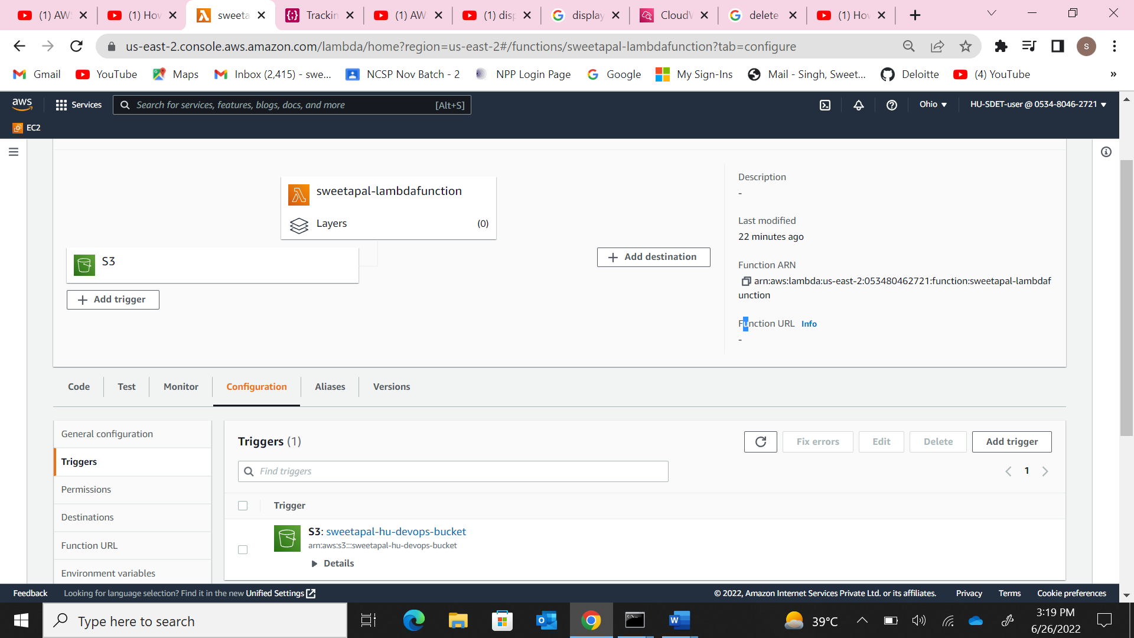

1. The “file is deleted message” on the cloudwatch logs.

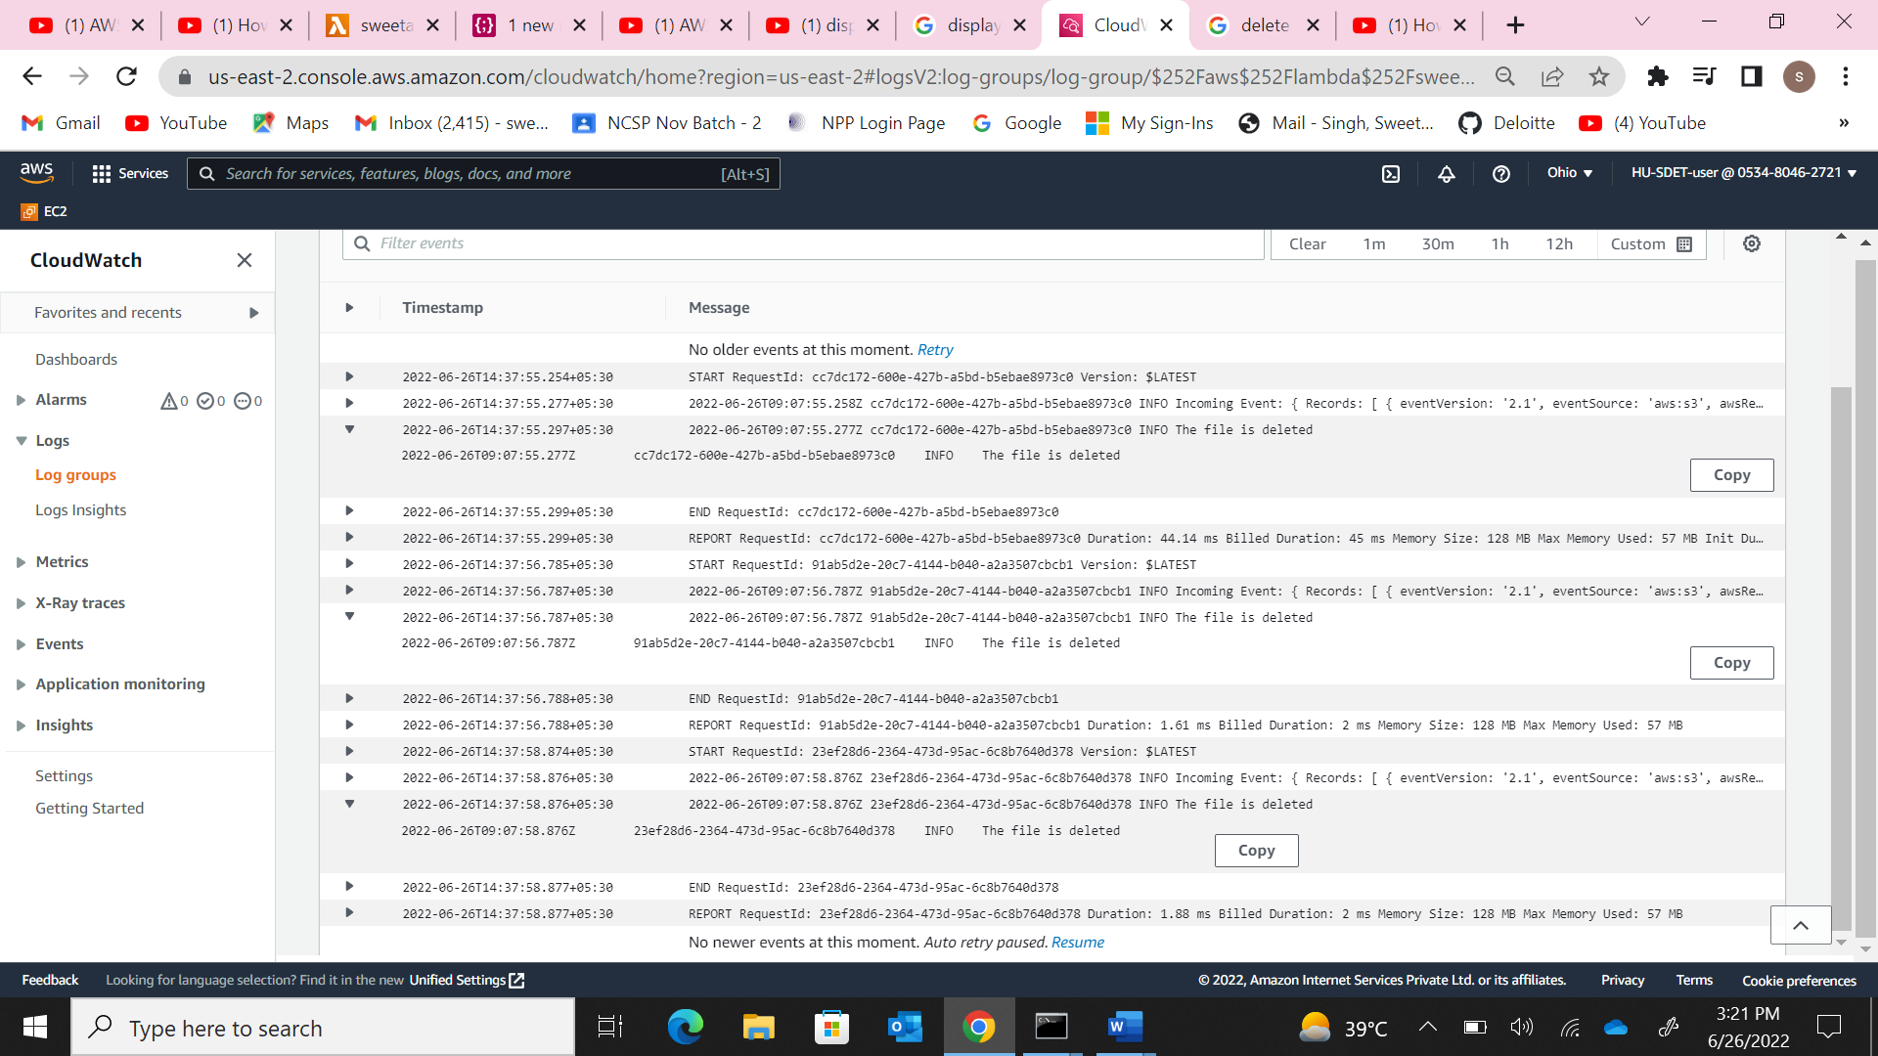

**Q5)** a). Create an AWS EBS volume of 15 GB and attached it to the instance created in Q1) and mount it properly on the location /<-your-name> and put some sample data into it and make the mounting permanent

1. The EBS volume created.

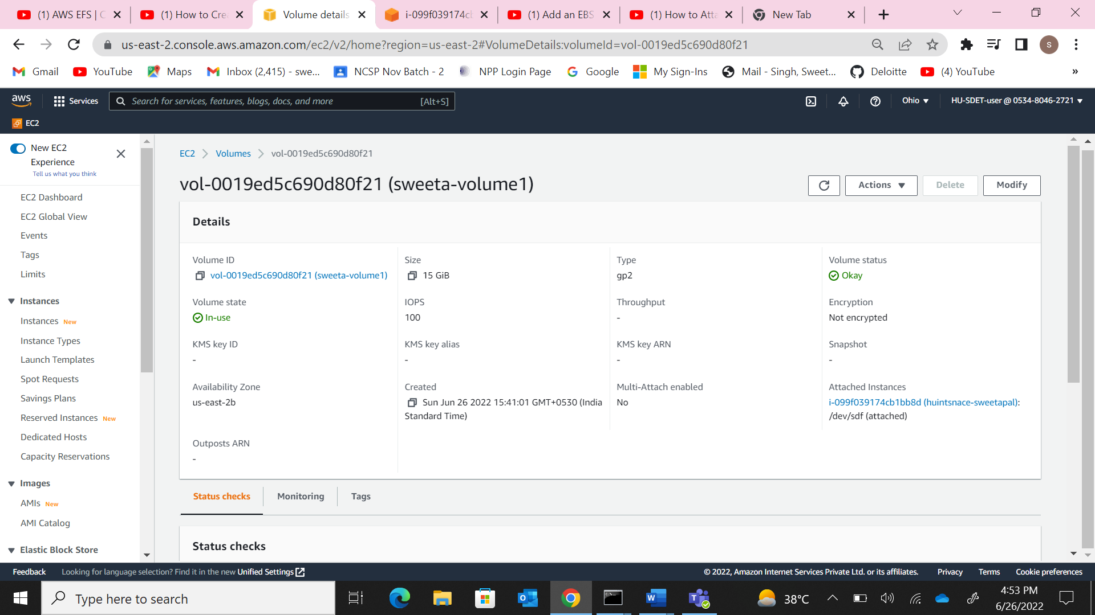

1. The EBS volume attached to ec2 instance, go to ec2 instance console and click storage.

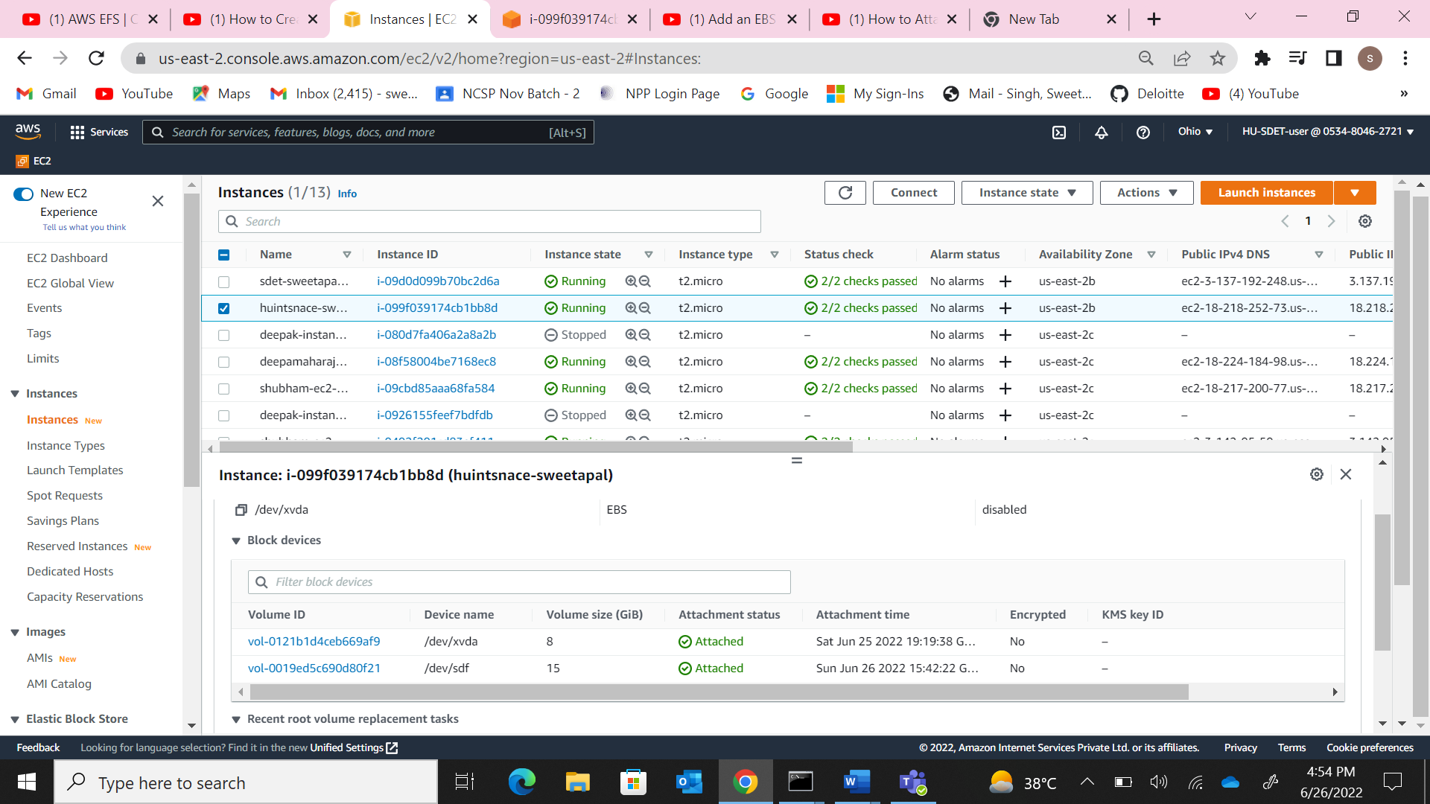

1. The commands run for mounting the EBS.

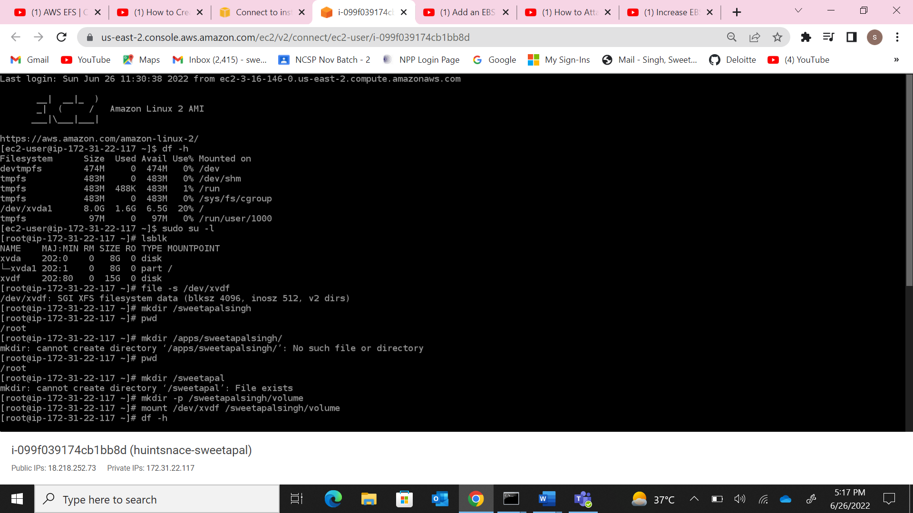

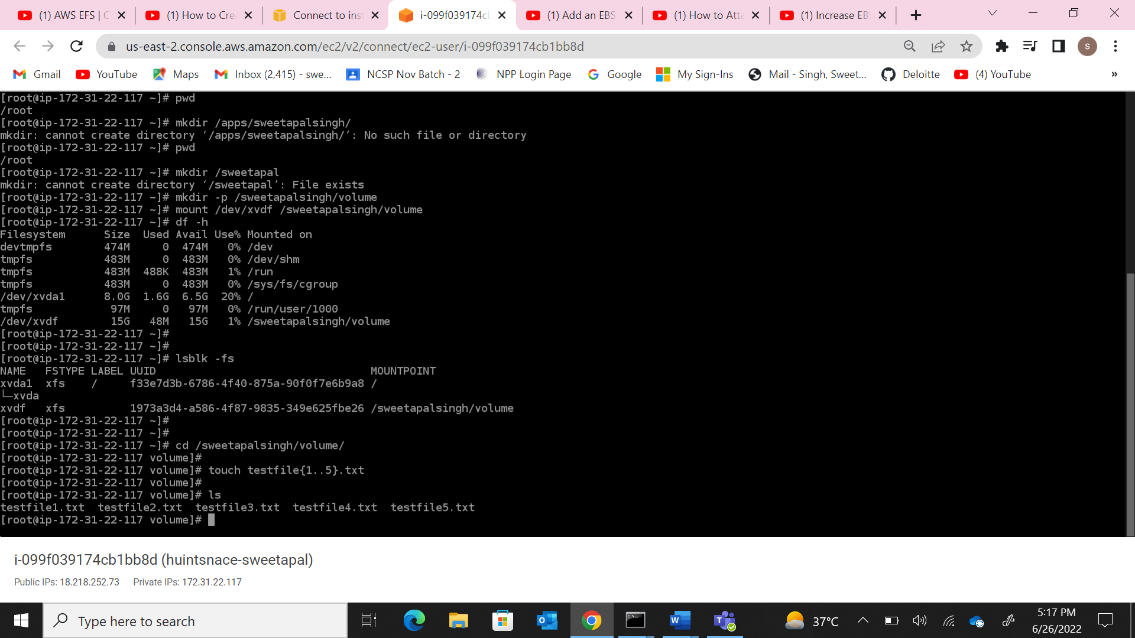

1. The EBS volume after the storage has been increased.

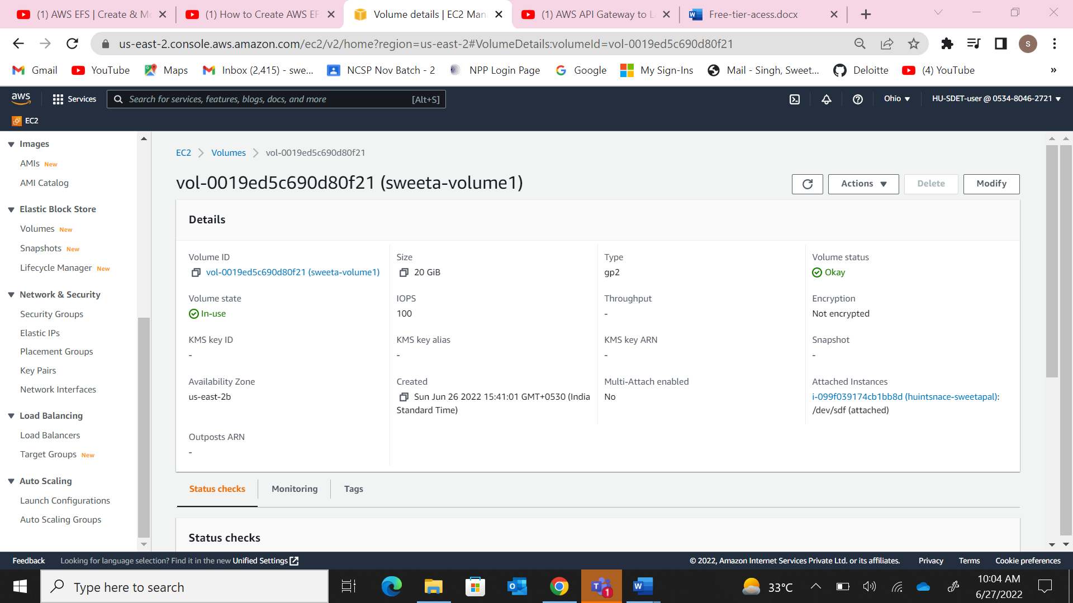

1. The commands run for increasing storage.

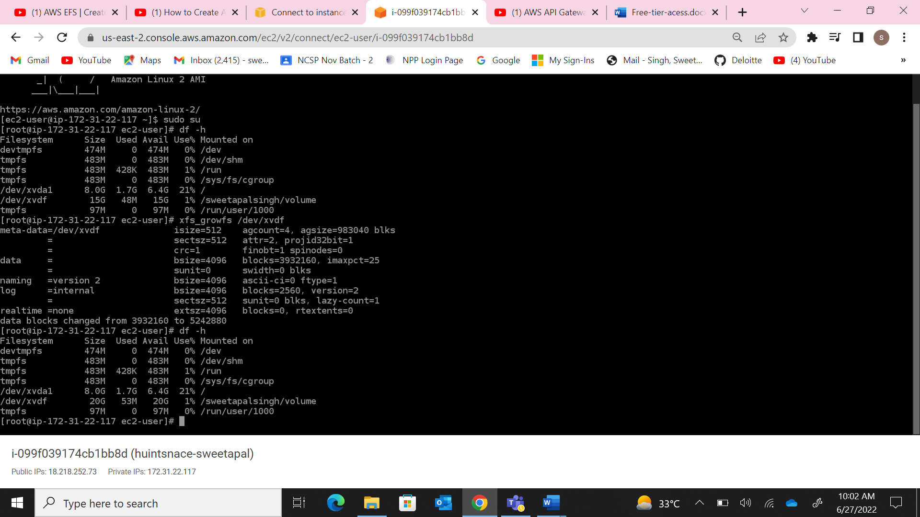

**Q6)** a) Launch RDS Instance - MySQL - db.m5.large. Do a telnet & check the connection from instancd launched in Q1.

1. The rds instance up and running.

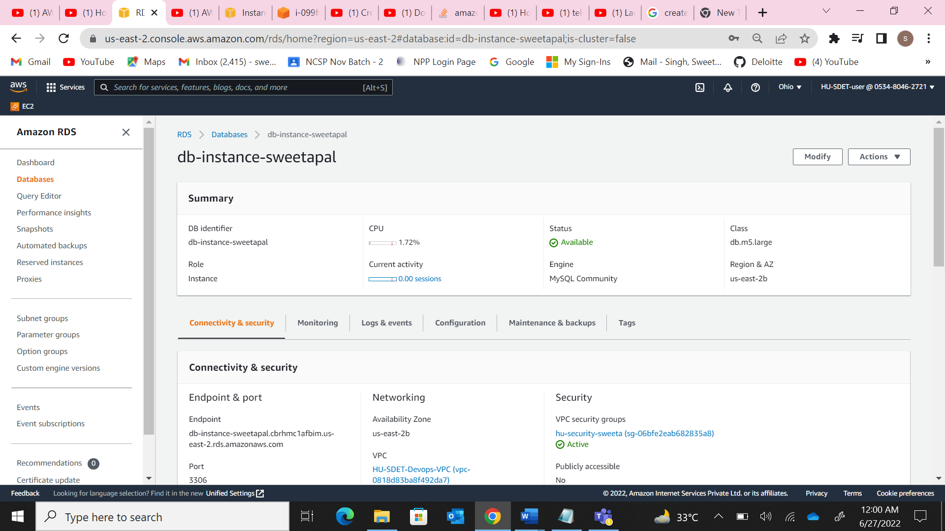

1. Security group of RDS.

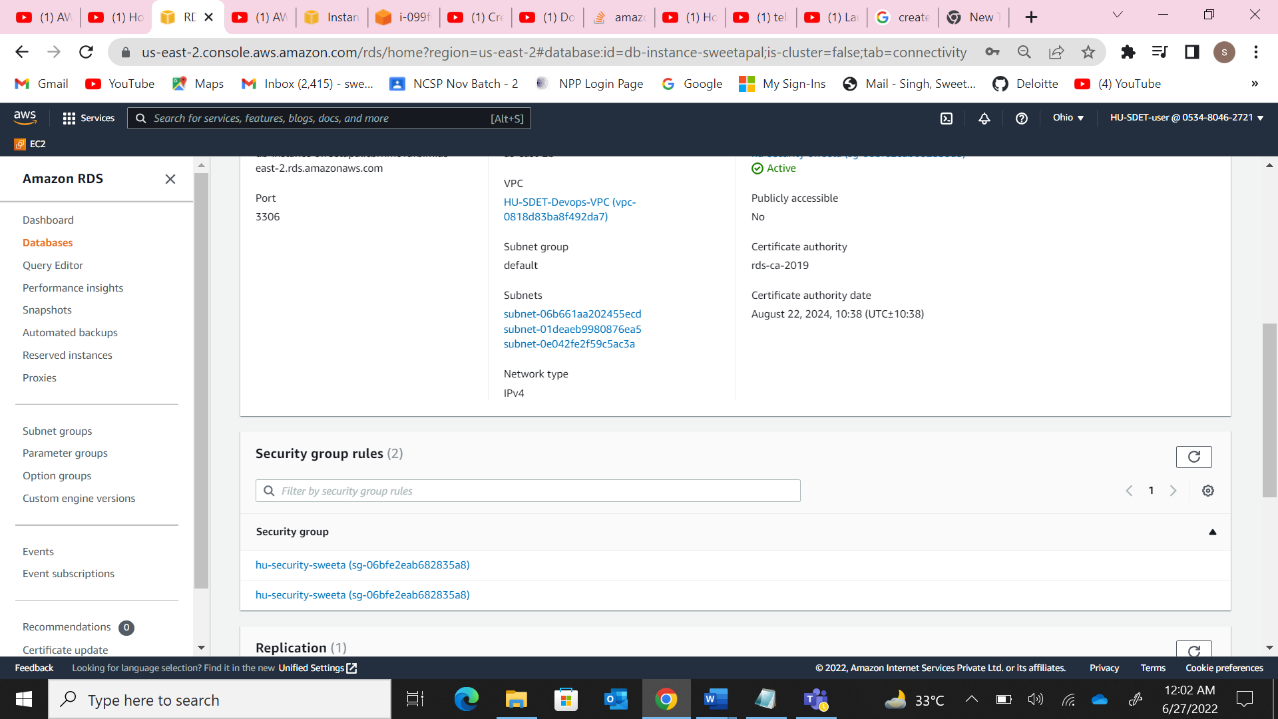

1. The telnet connection check.g

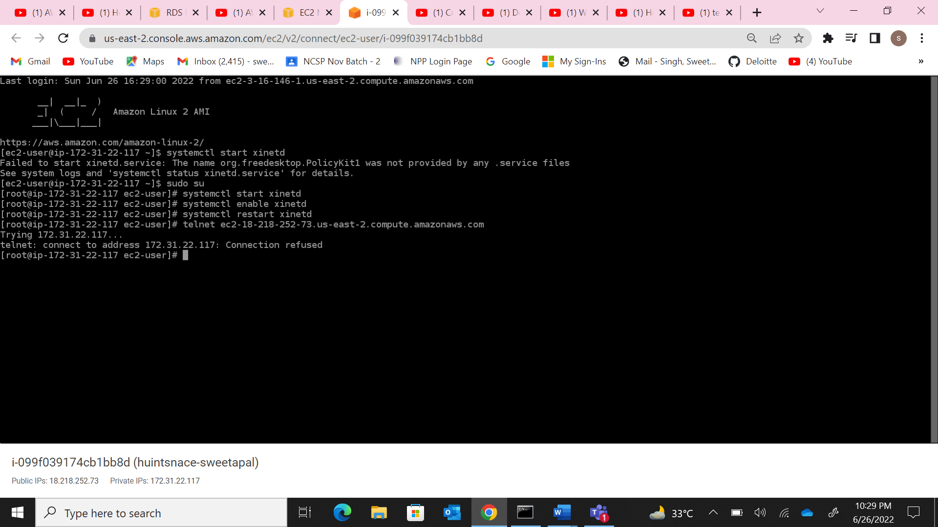

1. The dB, table and insertion of records from the instance.

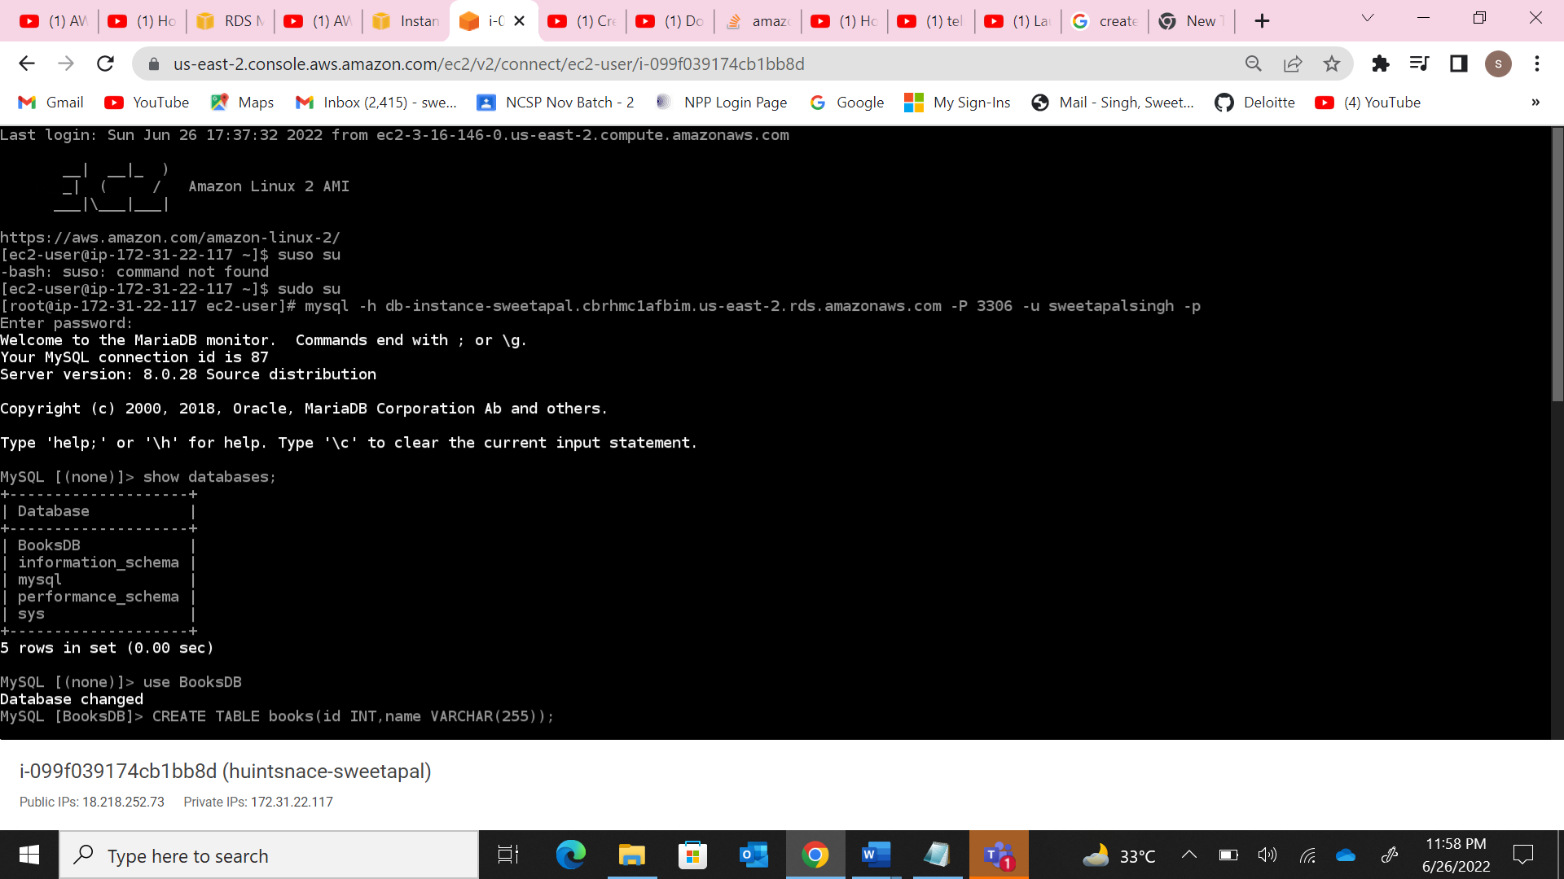

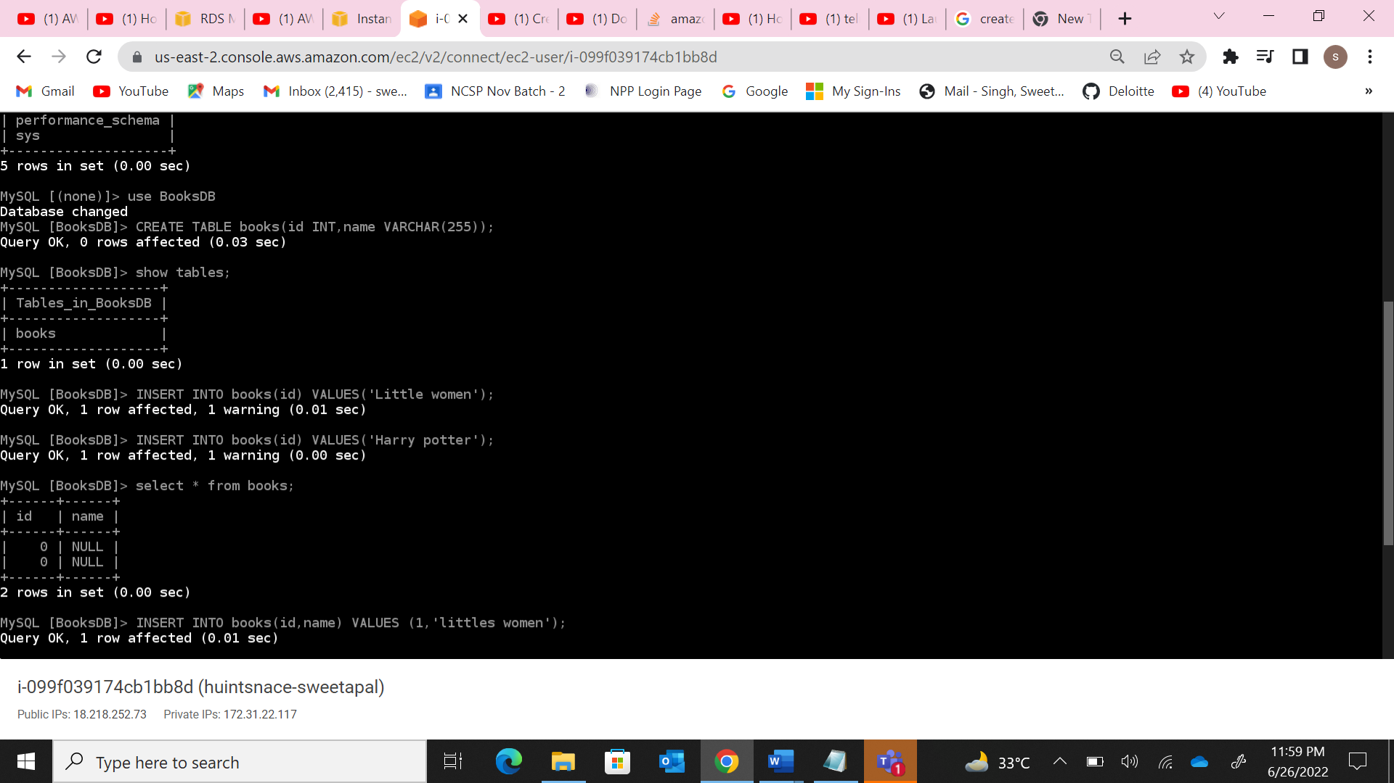

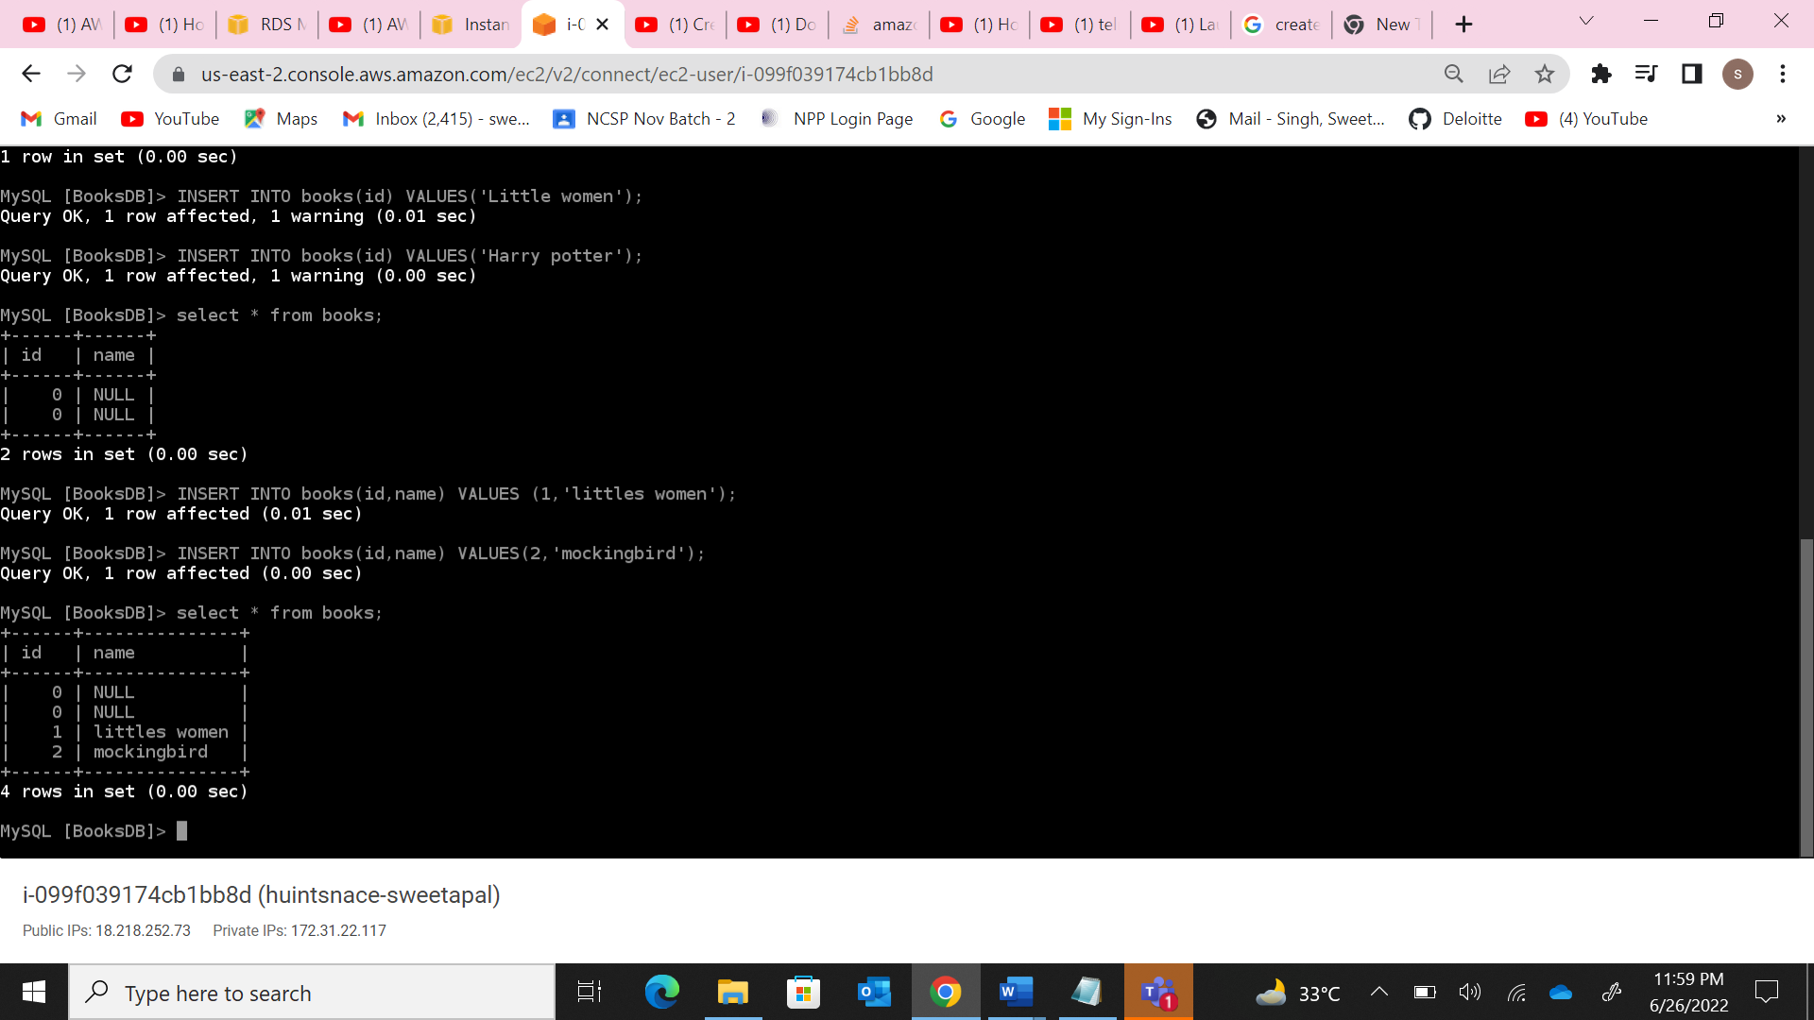

**Q7)** Create a lambda function and Integrate with Rest API Gateway.

a)Test the code in lambda function test events.

b)And test the get method in API Gateway.

